# Testruntime 1.2.1 use document

-2021.03.23

Test runtime is to simulate a KAT treadmill that is walking in a set direction. The purpose of using it is to allow developers (without KAT treadmills) to quickly test whether their projects are successfully adapted to KAT treadmills.

**Precautions:**

1. Testruntime can run and simulate KAT treadmill only on applications that have successfully adapted to KAT SDK. Applications that have not successfully adapted to KAT SDK cannot use any runtime programs.

2. For developers who already have treadmills (with dongle and Development runtime), please quit Development runtime when using Test runtime (equivalent to not connecting to KAT treadmill).

3. KAT IO software has a built-in runtime, please close KAT IO when using test runtime.

4. Just open and set the parameters, and there is no order to start with the test game.

5. The Test Runtime is simply a treadmill with a set direction. This tool does not allow developers to directly modify game parameters.

For example, in the Test runtime, adjust the parameters to go forward (Yaw value is 0°, forward state, moderate power), but when the game is running, the character walks to the right, or other strange directions, then the developer needs to be in the engine editor Modify the error in the test runtime, Test runtime can not help developers to solve the error, only to find the error. It is just a virtual treadmill with a manually set direction to walk.

6. For Unity developers:

(1) If an error such as "Cannot find the specified module" or similar error occurs during debugging or program running, please copy the 5 dll files included in the ToSystem32 compression package in the development package to the system disk (the default is C:) in the C:\Windows\System32 folder. If prompted that the file already exists, choose to overwrite the source file.

(2) If there are errors related to the SteamVR plug-in during the debugging process, please go to the official resource store to download the latest SteamVR plug-in.

**Features:**

Double-click to open the Test runtime application and display the interface as shown in the figure below.

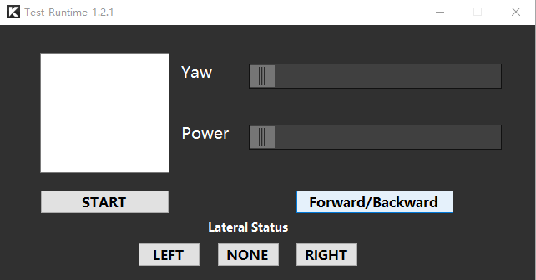

Click start to enable the functions. Click it as shown below:

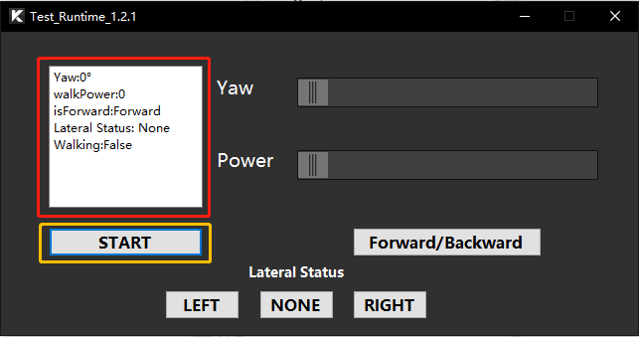

The blank area displays the parameters corresponding to the treadmill. You need to adjust the slider and buttons to adjust the parameters of the treadmill.

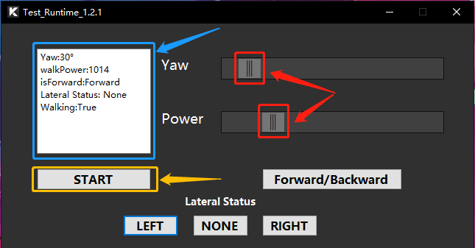

**Yaw:**The Yaw slider is the angle of the player, which is the direction of walking. 0° means forward (the default direction in the scene), 90° to the right, 180° to the back, and 270° to the left. The angle can be adjusted by analogy.

**Power:**Power slider is the speed of walking, the larger the value, the faster the speed. When the value is 0, the walking state is False, and the other values ​​are displayed as True.

**Forward/Backward:**Forward/Backward button can switch reverse walking.

**For example:** when Yaw is 60° and the isForward state is Forward, after pressing the Forward/Backward button, Yaw is still 60° and the isForward state is backward, but the walking direction is the previous reverse (that is, it is actually equivalent to Yaw=240°, forward state)

**Lateral Status:**The three buttons under Lateral Status are also to quickly switch directions. Click the LEFT direction to switch to the left of the current direction (that is, the angle changes to the current angle -90°), and the RIGHT direction to switch to the right of the current direction (that is, the angle changes to the current Angle +90°). NONE means to restore to the original angle.

**For example:** the current Yaw is 110°, after clicking LEFT, the angle instantly changes to 20°; after clicking RIGHT, the angle changes to 200°; after clicking NONE, the angle returns to 110°.